Steps to pull the frontend code from GitHub and run it on local.

1. Create a folder in your directory and pull the code from the GitHub repository “thunderbirds”.

Copy the URL from repository.

git clone <https://github.com/ucd-nlmsc-teamproject/ThunderBirds.git>

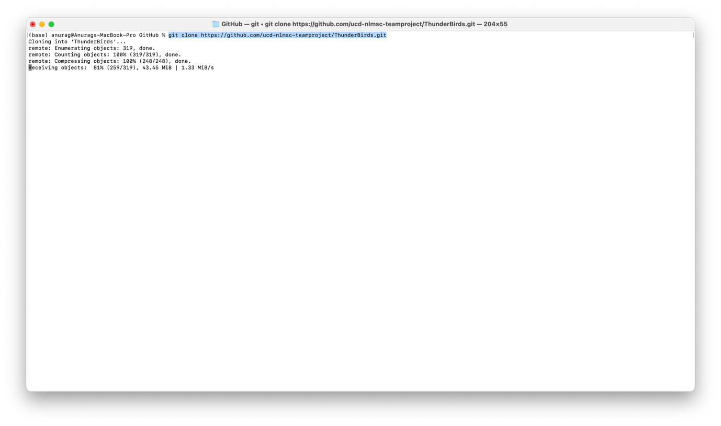

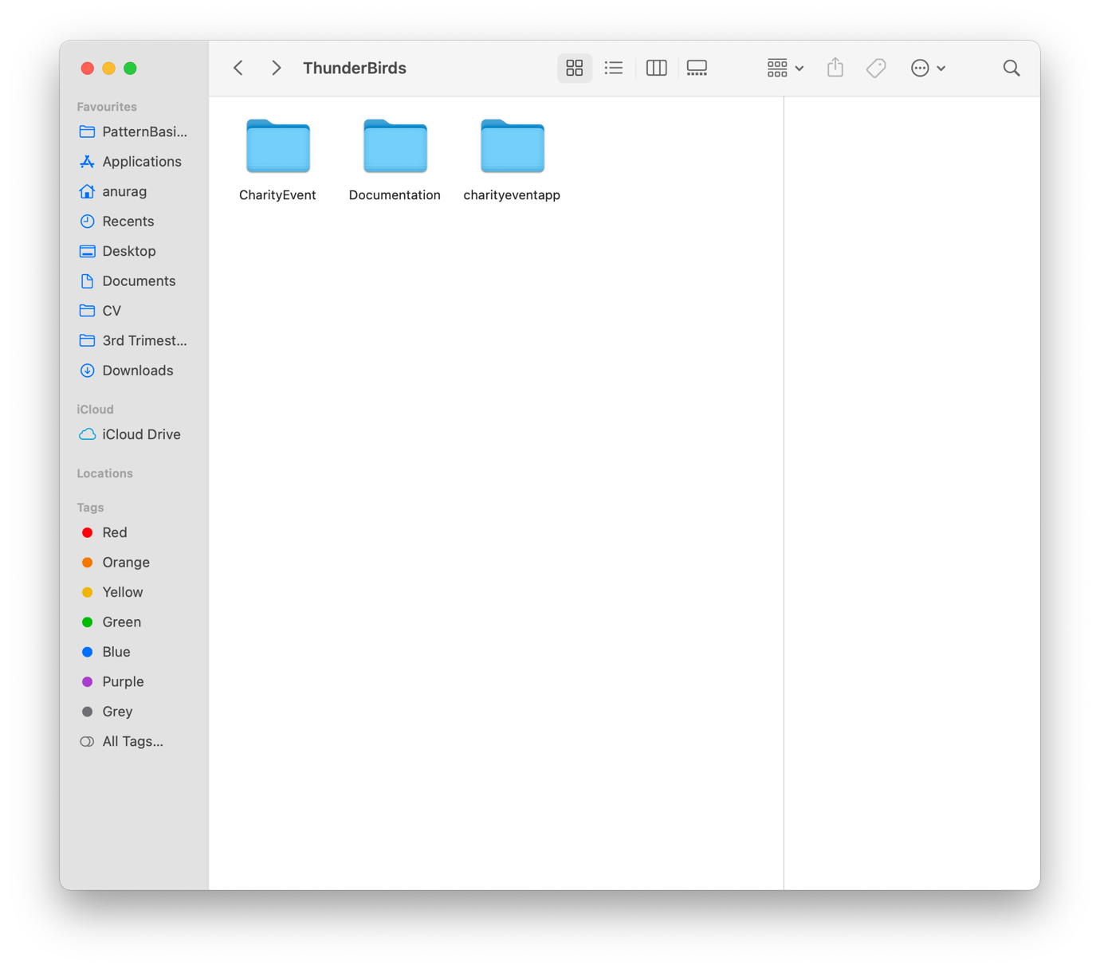

1. Open the charityeventapp folder in your VDI( eg. VScode) and in the VDI terminal and install dependency of the react app “install npm”. Open the charityeventapp in VScode. Graphical user interface, text, application

   Description automatically generatedopen VS code folder.Graphical user interface, application

   Description automatically generatedinstall npmA screenshot of a computer

   Description automatically generated with medium confidence
2. Run the application “npm start” or “yarn start”. A screenshot of a computer

   Description automatically generated with medium confidenceGraphical user interface

   Description automatically generated